- What is Internet?

The Internet is a global system of interconnected computer networks that use the standard Internet Protocol Suite (TCP/IP) to serve billions of users worldwide.

- What is web/WWW?

Web is a network, an interconnected system of things or people. We are well known about the term www. The www is a system of interlinked hypertext document accessed via the internet.

Problems with present web

Keyword-based search engines such as Yahoo and Google are the main
tools for using today’s Web. However, there are serious problems associated with their use:
• High recall, low precision. Even if the main relevant pages are retrieved,
they are of little use if another 28,758 mildly relevant or irrelevant documents are also retrieved. Too much can easily become as bad as too little.
• Low or no recall. Often it happens that we don’t get any relevant answer
for our request, or that important and relevant pages are not retrieved. Although low recall is a less frequent problem with current search engines,it does occur.
• Results are highly sensitive to vocabulary. Often our initial keywords do
not get the results we want; in these cases the documents that we see contains different terminology from the original query.
• Results are single Web pages. If we need information that is spread over
various documents, we must initiate several queries to collect the relevant
documents, and then we must manually extract the partial information
and put it together.
- So it need human labors and become time consuming.

- What is Semantic web?

The World Wide Web as we know it today, which contains virtually boundless information in the form of documents. We can use computers to search for these documents, but they still have to be read and interpreted by humans before any useful information can be extrapolated. Computers can present the information but can’t understand if the information is well enough to display the data that is most relevant in a given circumstance. The Semantic Web, on the other hand, is about having data as well as documents on the Web so that machines can process, transform, assemble, and even act on the data in useful ways.
The Semantic Web is a web that is able to describe things in a way that computers can understand. The Semantic Web is a mesh of information linked up in such a way as to be easily processable by machines, on a global scale. You can think of it as being an efficient way of representing data on the World Wide Web, or as a globally linked database.
The Semantic Web is not about links between web pages.
Semantic web is an effort to enhance current web so that computers can process the information presented on WWW, interpret and connect it, to help humans to find required knowledge.
The Semantic Web is about two things. It is about common formats for integration and combination of data drawn from diverse sources, It is also about language for recording how the data relates to real world objects. That allows a person, or a machine, to start off in one database, and then move through an unending set of databases which are connected not by wires but by being about the same thing. If a computer understands the semantics of a document, it doesn't just interpret the series of characters that make up that document: it understands the document's meaning.

- The aim of the Semantic Web:

Semantic web allow much more advanced knowledge management systems:
• Knowledge will be organized in conceptual spaces according to its meaning.
• Automated tools will support maintenance by checking for inconsistencies
and extracting new knowledge.
• Keyword-based search will be replaced by query answering: requested
knowledge will be retrieved, extracted, and presented in a humanfriendly
way.
• Query answering over several documents will be supported.
• Defining who may view certain parts of information (even parts of documents)will be possible
- Component of semantic web
Metadata:
The keyword based problem of the normal web can not be solved by only development of super intelligent agents. Instead it proposes to attack the problem from the Web page side. If HTML is replaced by more appropriate languages, then the Web pages could carry their content on their sleeve. And as this technology store data about data, so it can provide the required information that user want.

Ontology:
Ontology is an explicit and formal specification of conceptualization. Typically, ontology consists of a finite list of terms and the relationships between these terms. The relationships typically include hierarchies of classes. ontology provide a shared understanding of a domain.
Such a shared understanding is necessary to overcome differences in
terminology.

Ontologies are useful for the organization and navigation of Web sites.
Many Web sites today expose on the left-hand side of the page the top levels of a concept hierarchy of terms. The user may click on one of them to expand the subcategories.

Ontology is useful for improving the accuracy of Web searches.
The search engines can look for pages that refer to a precise concept in ontology instead of collecting all pages in which certain, generally ambiguous, keywords occur. In this way, differences in terminology between Web pages and the queries can be overcome.

Web searches can exploit generalization/specialization information.
If a query fails to find any relevant documents, the search engine
may suggest to the user a more general query. if too many answers are retrieved, the search engine may suggest to the user some specializations

Logic & Inference:
Provide formal languages for expressing knowledge

An important advantage of logic is that it can provide explanations for conclusions:
the series of inference steps can be retraced.
prof(X) → faculty(X)
faculty(X) → staff(X)
prof(michael)
Then we can deduce the following:
faculty(michael)
staff(michael)
prof(X) → staff(X)

Agent:
Agents are pieces of software that work autonomously and proactively.
A personal agent on the Semantic Web (figure 1.2) will receive some tasks
and preferences from the person, seek information from Web sources, communicate with other agents, compare information about user requirements and preferences, select certain choices, and give answers to the user.

- RDF
RDF is a standard model for data interchange on the Web. This linking structure forms a directed, labeled graph, where the edges represent the named link between two resources, represented by the graph nodes. This graph view is the easiest possible mental model for RDF . it is based upon the idea of making statements about resources (in particular Web resources) in the form of subject-predicate-object expressions. These expressions are known as triples in RDF terminology. The subject denotes the resource, and the predicate denotes traits or aspects of the resource and expresses a relationship between the subject and the object.
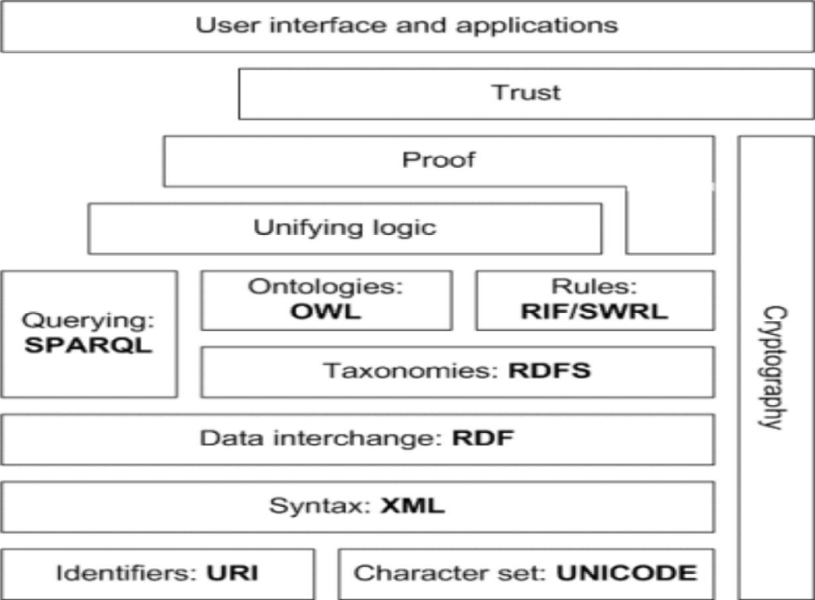
- Architecture of Semantic Web

The architecture of semantic web is illustrated in the figure below. The first layer, URI and Unicode, follows the important features of the existing WWW. Unicode is a standard of encoding international character sets and it allows that all human languages can be used (written and read) on the web using one standardized form.
A URI is simply a Web identifier, like the strings starting with http or ftp that you often see on the World Wide Web. Uniform Resource Identifier (URI) is a string of a standardized form that allows to uniquely identifying resources (e.g., documents).
A Uniform Resource Locator (URL) is a URI that, in addition to identifying a resource, provides network location.
Extensible Markup Language (XML) layer with XML namespace and XML schema definitions makes sure that there is a common syntax used in the semantic web. XML is a general purpose markup language for documents containing structured information. A XML document contains elements that can be nested and that may have attributes and content. XML namespaces allow specifying different markup vocabularies in one XML document. XML schema serves for expressing schema of a particular set of XML documents.
A core data representation format for semantic web is Resource Description Framework (RDF). RDF is a framework for representing information about resources in a graph form. It was primarily intended for representing metadata about WWW resources, such as the title, author, and modification date of a Web page, but it can be used for storing any other data. It is based on triples subject-predicate-object that form graph of data. All data in the semantic web use RDF as the primary representation language.
A standard means to describe the properties of data: RDF Schema. It provides mechanisms to describe groups of related resources and the relationships between those resources.
With the OWL Web Ontology Language, we can express ontology. OWL (Ontology Working Language) adds more vocabulary to describe properties and classes than RDF or RDF Schema. OWL has three sublanguages: in order of decreasing expressiveness, they are OWL Full, OWL DL, and OWL Lite.
- The OWL Web Ontology Language taken as a whole is called OWL Full. OWL Full uses all OWL language primitives
- OWL DL supports those users who want maximum expressiveness without losing computational completeness. OWL DL is a sublanguage of OWL Full language constructs with restrictions such as type separation .
- OWL Lite supports those users primarily needing a classification hierarchy and simple constraint features. The advantage of this language is that it is both easier to understand and easier to implement than the other two;
RDFS and OWL have semantics defined and this semantics can be used for reasoning within ontology and knowledge bases described using these languages. To provide rules beyond the constructs available from these languages, rule languages are being standardized for the semantic web as well. Two standards are emerging - RIF and SWRL.
For querying RDF data as well as RDFS and OWL ontology with knowledge bases, a Simple Protocol and RDF Query Language (SPARQL) is available. SPARQL is SQL-like language, SPARQL is not only query language; it is also a protocol for accessing RDF data.
It is expected that all the semantics and rules will be executed at the layers below Proof and the result will be used to prove deductions. Formal proof together with trusted inputs for the proof will mean that the results can be trusted, which is shown in the top layer of the figure above. For reliable inputs, cryptography means are to be used, such as digital signatures for verification of the origin of the sources.

- Application of semantic
Like other technologies, the interest in creating and developing the Semantic Web is motivated by the opportunities it might bring: either it can solve new problems, or it can solve old problem in a better way. Here, instead of enumerating all the opportunities enabled by the Semantic Web, we focus our discussion on the following closely related aspects: web-services and semantics-based web search engines.

Web-services
The most important web resources on the Semantic Web are called web-services. Here, web-services refer to "web sites that do not merely provide static information but allow one to effect some action or change in the world". The Semantic Web will enable users to locate, select, employ, compose, and monitor web-services automatically.
Semantics-based web search engines
Search engines are among the most useful resources on the Web and currently there are two types of search engines:
- Large-scale robot-based search engines. These systems rely on robots to retrieve Web pages and store them in a centralized database. The advantage of this mechanism is that it increases recall since robots can almost retrieve all web pages on the Web, while the disadvantage is the precision (the proportion of retrieved documents that are actually relevant) of the search result might be low.
- Small-scale reviewer-based search engines. A category hierarchy is created and each category is described by a set of keywords. Reviewers will review each web page (submitted by web page authors) and associate it with appropriate categories. The advantage is that precision is increased, but the disadvantage is that recall might be low since it is impossible to review and include every single relevant web page on the Web.

